1. Use employees databaseUse the insert, update and delete command in a single

transaction.

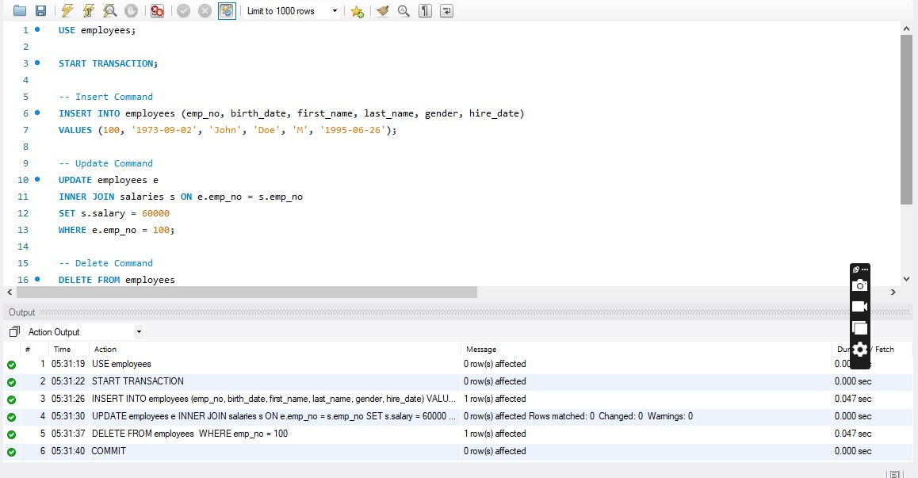

1. **Create a transaction which prevents the same employee number being added more than once in the employees table.**
2. 